Research on GOOSE Network DC Protection for Intelligence Energy Source Station
Aiming at the typical fault types such as short circuit and grounding in medium and low voltage DC distribution network, a network DC protection solution based on GOOSE is proposed, which increases the direction definition of system power on the basis of conventional direct current protection, and transmits information between adjacent protections through GOOSE network to ensure the selectivity of protection. The simulation results show that the modification scheme can save the cost and solve the problems of inaccurate conventional DC protection fault positioning, difficult protection coordination under complex topology, and multiple protection errors in the single position fault of the system.
Key words： Intelligence, Energy source station, GOOSE, DC Protection
- Introduction
With the rapid development of power systems, DC mode power supply systems are being used more and more widely. The DC mode can fully exploit the advantages of distributed power generation, energy storage, distribution as well as power supply systems, bringing new values and benefits to power suppliers and users. The technical problems of DC power distribution in terms of effective acceptance of distributed voltage, efficient and stable voltage transformation and control, optimal system configuration and reliability of power supply have been largely solved^{[1]}. The protection of DC power distribution is the key to its safe operation, but the research on DC power distribution protection at home and abroad is still at the stage of theoretical research and experimental exploration.
In literature [2] , the author proposes an active protection scheme based on power electronics technology, analyses the principle and method of implementing each function of active protection. The protection scheme of the DC line is proposed to form the value principle and calculation method of DC protection ^{[3]} .Literature [4] comprehensively reviewed the current status of key technologies of AC/DC microgrid cluster system operation mode division, put forward a multi-mode division method of system operation and cooperative mutual aid regulation strategy, and divided the system into 320 operation modes according to the characteristics of three modes, namely communication mode, topology structure and load state. Literature [5] proposes a new type of protection scheme for flow lines, introduces the construction and development of AC-DC hybrid distribution network and its relay protection operation configuration, and builds a simulation model of AC-DC hybrid distribution network through a real-time digital simulator. Literature [6] proposed a new method based on traveling wave (TW) for detecting, classifying and locating different DC fault types in MVDC microgrids, which is different from the traditional method in that it focuses on the waveform characteristics and polarity of the TW rather than its arrival time. Literature [7] proposed a longitudinal directional protection based on the difference between the high-frequency energy of the forward and inverse traveling waves based on the forward and inverse directional characteristics of the occurring faults, which uses wavelet packet transform to extract the high-frequency energy of the traveling wave, and utilizes the difference in the high-frequency energy of the forward and inverse traveling waves to discriminate the faults during the in-area faults and the out-of-area faults. Literature [8] for multi-terminal flexible DC distribution network fault rapid identification, localization and isolation of the key technical challenges, the use of distribution network adjacent DC distribution terminal nodes of fault identification characteristics of information, proposed a general object-oriented substation events based on the DC distribution network distributed area protection method of communication methods, can realize the fault rapid localization and isolation function. Literature [9] proposes a cross-institution networked protection scheme for DC traction power supply system based on GOOSE (Generic Object Oriented Substation Event) communication technology, which replaces the traditional hardwiring to realize the transmission of protection inter-tripping and blocking information between transformer substations through GOOSE communication technology.
At present, there is a lack of unified standards for DC protection technology and equipment, and DC distribution networks are mostly in the pilot and demonstration stage, with insufficient experience in actual operation, which makes the protection configuration of DC distribution systems face many challenges. In order to realize cost-effective operation, DC distribution systems should adopt protection equipment that is both economical and reliable, and able to cope with various fault scenarios.
- Medium and low voltage DC distribution system fault types and protection configuration principles
  - Types of faults in low and medium voltage DC distribution systems
Medium and low voltage DC distribution network close to the user terminal, fault complexity and diversity, DC distribution network in addition to the existence of short-circuit, grounding faults and insulation degradation abnormal operation ^{[10]}, but also the existence of AC and DC mixing, DC ring network and other faults.
In general, insulation drop and AC/DC mixing faults have no fault current, only abnormal changes in the voltage to ground, if these faults can not be controlled and dealt with, the fault will evolve into a ground fault. The positive and negative poles suspended DC distribution system, single pole grounding also no fault current, only abnormal voltage to ground, only when the other pole also appears grounded, will cause short-circuit current.
DC ring faults in DC distribution system will lead to DC system between the formation of ring current, abnormal discharge and other phenomena, and even cause short-circuit and grounding faults, if the ring fault occurs in two different voltage levels of the DC system, the ring current and abnormal discharge current will be greater, and the consequences are more serious. Five kinds of DC system fault development relationship is shown in Figure 1.
Figure 1 DC system fault relationship diagram
DC faults have unique voltage and current characteristics, but the fault point is difficult to find, DC loads are very sensitive to voltage, and each fault has a wide range of impact. In addition to short-circuit faults can be removed, the other fault types have no perfect protection scheme and system, only monitoring and alarm devices.
  - Medium and low voltage DC protection configuration principles
The protection configuration of the medium and low voltage DC system varies depending on the object to be protected, but its core objective is the same: to ensure the safe and reliable operation of the system. Under the premise of meeting the protection requirements, the protection configuration should be simplified as much as possible. Too many protection devices will not only increase the system investment, but also increase the complexity of protection coordination. Therefore, reasonable streamlining of the protection configuration is the key to achieving a balance between economy and reliability.
At present, the application of DC protection in the power system is still in its infancy, but it is widely used in the DC power supply system of the rail transit system ^{[11, 12]}, and according to the only “DC traction power supply system for urban rail transit” (GB/T 10411-2005) mentioned in the regulations and norms, the commonly used types of protection are as follows:
- High current release
DC inlet and feeder switches are set with high current release protection, mainly used for near-end short-circuit protection, which utilizes the electromagnetic principle on DC switches to realize protection tripping. When a short-circuit fault occurs in the DC power supply system, fault removal is carried out through the DC fast circuit breaker. The DC feeder circuit breaker itself is equipped with a high current release. Due to the large short-circuit current on the equipment will cause great damage, so when it appears it should be cut off immediately, and its cut-off moment should be before it reaches the peak current.
- di / dt current rise rate and current increment protection (DDL)
DC system short-circuit has a short-circuit current rising speed, short-circuit current is characterized by large, therefore, di / dt current rise rate and current increment protection is an important protection of DC system. DDL protection is the middle and remote protection of the system, in the case of short-circuit at the near end, this protection can not operate, that is, it can not be used as a backup protection for high-current disconnection.DDL protection is divided into DDL + ΔI and DDL + ΔT protection, which determines the faults by analyzing the relationship between the feeder current increment ΔI and the time t.
- Current protection
Current protection is mainly categorized into current interruption protection and overcurrent protection. As the main protection measure for near-end short-circuit in DC systems, the current-speed interruption protection is set based on the minimum short-circuit current flowing through the feeder circuit breaker during a near-end short-circuit. The protection device continuously monitors the maximum value of the current, and the protection mechanism will be triggered once this current exceeds the set threshold of the quick-break protection or the overcurrent protection, and the duration exceeds the preset time limit.
- Low voltage protection
According to the minimum working voltage allowed for system operation, the time should be greater than the AC side or DC side of the possible fault switching caused by the blackout interval, should also be considered as a backup protection for other feeder protection.
- Bilateral joint jump protection
Bilateral joint trip protection ensures that the neighboring DC circuit breakers are tripped reliably under fault conditions. In the event of a fault, the protection unit detects a protective action signal and sends a trip signal to the adjacent DC circuit breaker via a hard contact, thus triggering the tripping of the DC switch.
- Characteristic analysis of networked DC protection based on GOOSE
The current-fast-break protection only relies on the rectified values of current and time to act, so it has poor selectivity and is prone to false-action phenomenon. Other existing protection methods, such as current rise rate protection and current incremental protection, can theoretically improve the selectivity, but the complexity of its rectification calculation has not yet been widely used in the actual power system. Therefore, there is an urgent need for a DC protection scheme that can ensure both selectivity and fast response to solve the problem that the existing protection is prone to false activation ^{[13]}.
At present, most DC protection measures are based on single-ended quantity protection, with insufficient selectivity ^{[14-16]}. In the actual operation in the field, these protection methods are difficult to quickly and accurately locate the fault point, and it is also difficult to realize the effective cooperation between the upper and lower levels of protection. When a fault occurs at a certain location in the system, it is easy to trigger multi-level tripping ^{[17]}, thus affecting the stability and reliability of the whole system.
In order to solve the above problems, this paper proposes a networked protection device based on the GOOSE (Generic Object Oriented Substation Event) protocol and develops a corresponding networked DC protection scheme. The scheme aims to improve the selectivity and response speed of the protection by utilizing the advantages of the GOOSE protocol to ensure that the fault area can be quickly and accurately isolated when a fault occurs, avoiding unnecessary tripping.
Unlike conventional DC protection, GOOSE-based networked DC protection has its own unique features, as follows:
  - Definition of direction
The GOOSE networked DC protection system based on GOOSE demonstrates unique advantages in terms of improved protection selectivity and reliability compared to conventional DC protection methods. To ensure the efficient operation of this new type of protection system, the definition of the direction of power must be clearly defined. Specifically, in each branch circuit connected to the DC bus, if the power flows from the DC bus to the external line, the direction is defined as positive; conversely, if the power flows from the external line back to the DC bus, it is considered to be in the opposite direction ^{[9-10]}. This definition is crucial to ensure that the fault location is correctly identified in a networked DC protection system, as it helps the protection device to quickly and accurately determine which zone is faulty, so as to achieve rapid isolation of the faulty portion without affecting other healthy portions, and ultimately to achieve the purpose of improving the stability and reliability of the entire power system. The power direction is defined as shown in Figure 2:
Figure 2 GOOSE-based networked DC protection power direction definition diagram
  - Networking methods
The DC protection device based on GOOSE network is equipped with two Ethernet communication ports, which support setting up a dual network structure for accessing the power monitoring system via the DL/T860 standard protocol. Given the central role of the GOOSE network in the DC protection system, any communication interruption may trigger serious consequences, such as a large-scale grade-crossing tripping incident, which poses a major threat to the stable operation of the power system. Therefore, in order to enhance the reliability and fault tolerance of the system, it is considered to add two extra pairs of fiber optic interfaces for each DC protection device to build a redundant dual network architecture. This not only ensures that GOOSE signals can still be smoothly transmitted to adjacent DC protection devices through the backup network when the main network fails, realizing timely and effective information interaction, but also significantly improves the anti-interference ability of the whole protection system and its ability to cope with emergencies, so as to effectively avoid widespread blackout caused by a single network failure and guarantee the safe and stable operation of the power system.
In a DC sub-microgrid system, the protective devices of all branches are designed to be able to send the fault-initiated GOOSE signals detected by themselves through a pre-constructed GOOSE network. This design ensures that each protection device not only reports local faults, but also subscribes to and receives GOOSE signals from neighboring branch protection devices from the GOOSE network as needed. In this way, each protective device is able to obtain real-time fault information from neighboring areas, which enables more accurate fault discrimination and localization, and improves the speed and accuracy of fault handling. The networked DC protection devices are grouped as shown in Figure 3:
Figure 3 GOOSE-based networked DC protection network diagram
  - Classic Configuration Options
- The DC bus protection area is equipped with one set of GOOSE-based networked protection for each interval, and the protection devices for each interval are distributed and installed locally in the switch cubicle of the interval.
- When the system faults, each branch in each area adopts the way of networking to send the fault initiation GOOSE signal (with direction) of this branch to the GOOSE network.
- The active intervals in each region receive the fault initiation GOOSE signal for all intervals in the region via the GOOSE network respectively, whereby the fault is located.
Each DC protection device, through the feeder (incoming and outgoing) current and feeder voltage signal acquisition, completes the protection function and analogue measurement function of the feeder. According to the characteristics of the specific project, the DC protection device of DC inlet line and feeder interval can choose the installation mode of switch cubicle on site, or the installation mode of centralized panel group, or the installation mode of switch cubicle + centralized panel group.
- GOOSE-based simulation of networked DC protection RTDS
  - Simulation model
A GOOSE-based networked DC protection scheme is selected for the wide range of protection actions occurring in the “T-center”. In order to verify the rapidity and selectivity of the scheme, a detailed simulation model will be built. Through this model, comprehensive tests will be conducted to evaluate the performance of GOOSE-based networked DC protection in practical applications. The RTDS (real time digital simulation system) simulation model diagram is shown as Figure 4.
Figure 4 RTDS simulation model diagram of networked DC protection based on GOOSE
  - Simulation results
- PCS2 closed, A2, A3, A7 closed. A9 disconnected. Fault point: F4 positive earth faults.
The simulation waveform is shown in Figure 5.
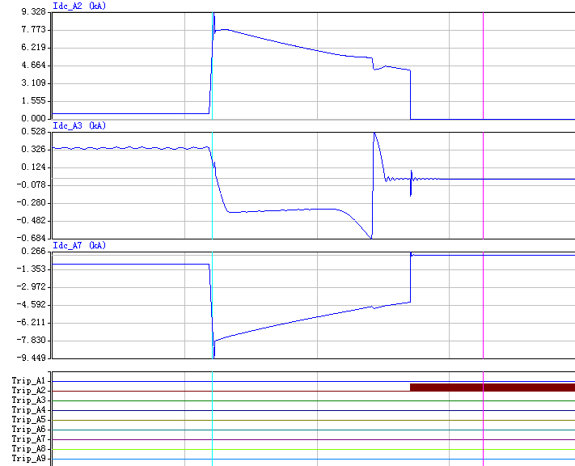
Figure 5 GOOSE-based networked DC protection RTDS simulation waveform graph 1
Simulation result shows that A3 and A7 protection starts (receive A2 positive direction and start GOOSE blocking signal. Protection only starts without action). A2 line protection removes the breakdown.
- PCS2 closed. A2, A3, A7 closed.A9 disconnected (operation is close to the DC model of the smart energy station). Fault point: F5 positive earth faults.
The simulation waveform is shown in Figure 6.
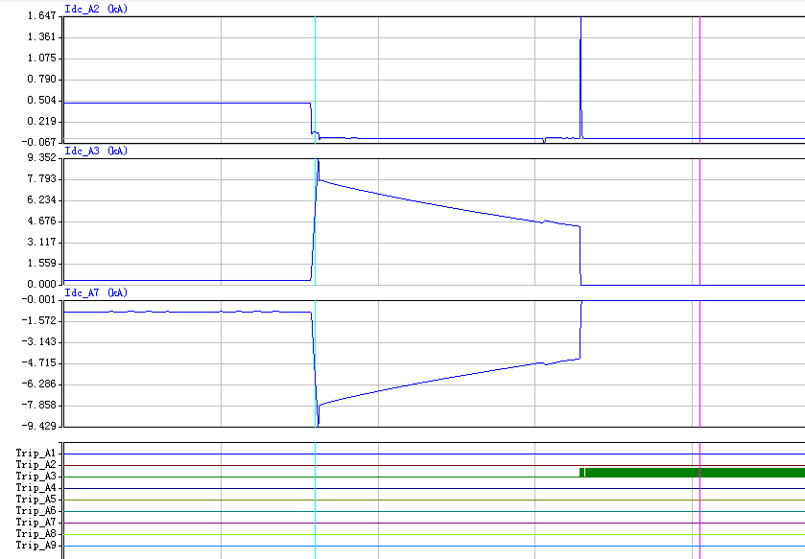
Figure 6 GOOSE-based networked DC protection RTDS simulation waveform graph 2
Simulation result: A7 protection starts (receive A3 positive direction and start GOOSE blocking signal. Protection only starts without action). A3 line protection removes the breakdown.
- PCS2 closed, A2, A3, A7 closed. A9 disconnected (operation is close to the DC model of the smart energy station). Fault point: F6 bus bar positive ground faults.
The simulation waveform is shown in Figure 7.
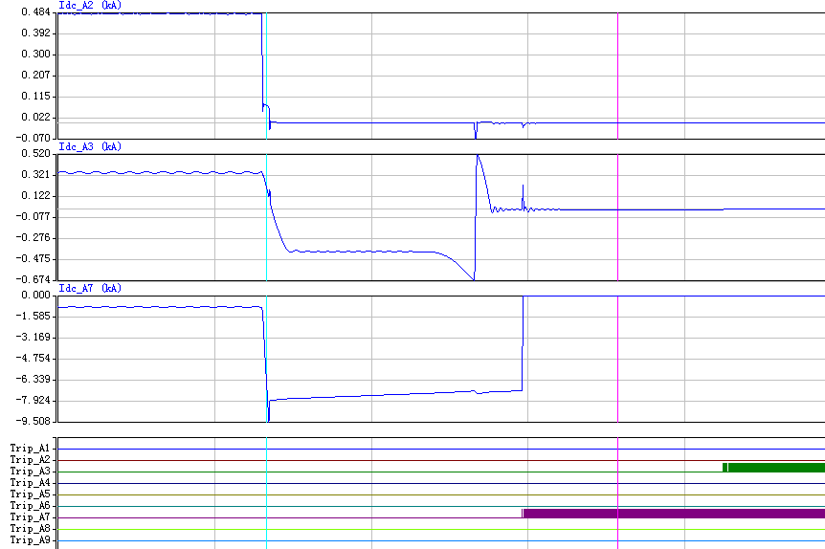
Figure 7 GOOSE-based networked DC protection RTDS simulation waveform graph 3
Simulation result shows that A3, A7 bus bar protection removes the breakdown.
  - Simulation conclusion
According to the simulation results, it can be seen that the GOOSE-based networked DC protection can act correctly in all kinds of fault situations, without any false or rejected cases. The selectivity and sensitivity of the protection are taken into account with a small increase in the cost of a single device, solving the problem of locating and isolating faults in the DC system.
- DC protection configuration solutions for smart energy stationS
The DC sub-microgrid system of the smart energy station is wired as a single bus bar. Each section of bus bar and all branches connected to it are divided into a separate protection zone. The DC circuit breakers in each protection zone are equipped with GOOSE-based networked DC protection. The protection zones are divided into the blue areas shown in Figure 8 below.
Figure 8 Map of the conservation area
The branches in the protection area communicate with each other by means of a network. When a fault occurs in the system, the protection device sends the fault initiation GOOSE signal (with direction) of the branch to the GOOSE network. The active interval receives the fault initiation GOOSE signal separately from all intervals in the region via the GOOSE network, whereby fault location is carried out to ensure selectivity of protection. Due to the time required for GOOSE network transmission, a 10ms time delay needs to be set for networked protection to ensure normal transmission of the GOOSE signal between the protections.
  - Protection function configuration and operating mode
According to the DC sub-microgrid architecture and source network load characteristics, the GOOSE-based networked DC protection function configuration and working principle are as follows:
- Protective function devices
A schematic of the active branch circuit protection configuration is shown in Figure 9.The active branch circuits (DL1, DL2, DL6, DL11) are configured for over-current protection in the forward and reverse directions, i.e.
Forward directional protection--as the main protection of this branch. the protection is activated to remove the fault when the branch fails.
Reverse directional protection--Fault discriminates via positive directional blocking, in conjunction with directional over-current GOOSE signals from other branches, as main protection for the bus bar and back-up protection for adjacent intervals.
Figure 9 Diagram of active branch circuit protection configuration
A schematic of the passive branch protection configuration is shown in Figure 10.The purely loaded passive branches (DL3, DL4, DL5, DL7, DL8, DL9, DL10) are equipped with positive directional over-current protection as the main protection for this branch, and the protection is quick-acting to remove the fault when this branch fails.
Figure 10 Diagram of passive branch circuit protection configuration
DL1 ~ DL11 each protection device is configured with out-of-service protection as shown in Figure 11, when any interval protection tripped and the circuit breaker is in the closed position, then by the circuit breaker out-of-service discrimination time (at least 50ms), send the start of the out-of-service open GOOSE signal, the other intervals receive the signal of the circuit breaker out-of-service and the protection is in the start-up state, and trip the circuit breaker immediately.
Figure 11 Logical diagram of dysfunctional protecting action
- Fault activation
As shown in Figure 12, when the protection fault of each interval is activated and the power direction is positive, the GOOSE activation signal of this interval is immediately sent to the GOOSE network for the fault discrimination of other intervals.
Figure 12 Schematic diagram of fail-start logic
- Logical diagram of fault initiation
The Discriminatory method is that When there is an overcurrent in any active branch of the bus and the power
direction is in the opposite direction and no positive direction start signal is received from other intervals, it is considered that the fault point is on the bus and the reverse direction overcurrent protection should act to remove the fault.
  - Protect configuration scheme
The DC sub-microgrid of the smart energy station adopts a 750V unipolar single-bus wiring form. A set of GOOSE-based networked DC protection is configured at the incoming switch, supercapacitor, PV, data center, DC lighting, charging pile, and station DC system intervals. In addition, GOOSE switches are configured according to the bus section to ensure efficient communication and cooperative work among the protection devices.
- conclusion
The DC micro-grid system adopts GOOSE-based networked DC protection, which is known through simulation to operate correctly and reliably under various fault conditions. While saving costs, it can solve the problems of inaccurate fault location of conventional DC protection, difficulties in protection coordination under complex topology, and the tendency of multiple protections to false motivation during faults in a single location of the system, and can be promoted and applied after accumulating operational experience in pilot projects.
REFERENCES
[1] XUE Shimin, CHEN Chaochao, JIN Yi, et al. A Research Review of Protection Technology for DC Distribution System [J]. Proceedings of the CSEE, 2014, 34(19): 3114-22.
[2] WU Ming, LIU Haitao, CHEN Wen, et al. Research on Active Protection for MV/LV DC Distribution System [J]. Proceedings of the CSEE, 2016, 36(04): 891-9.
[3] JIA Ke, ZHAO Qijuan, WANG Congbo, et al. Line Protection and Setting Calculation for Flexible DC Distribution System [J]. Automation of Electric Power Systems, 2019, 43(19): 171-8.
[4] YANG Zhichun, WANG Chenxia, JIANG Dong, et al. Operation Mode Division and Cooperative Regulation Strategy of AC/DC Microgrid Cluster System [J]. High Voltage Engineering, 2024, 50(03): 1111-21.
[5] CHEN Xiaoqian. Research on New AC Protection Scheme for AC/DC Hybrid Distribution Network [D], 2023.
[6] SALEH K A, HOOSHYAR A, EL-SAADANY E F. Ultra-High-Speed Traveling-Wave-Based Protection Scheme for Medium-Voltage DC Microgrids [J]. IEEE Transactions on Smart Grid, 2019, 10(2): 1440-51.
[7] GAO Shuping, LI Yuanze, SONG Guobinb, et al. A Pilot Directional Protection Method for Hybrid Bipolar DC Transmission [J]. Journal of Hunan University(Natural Sciences), 2024, 51(02): 33-44.
[8] LI Hui, WU Hai, HU Guo, et al. Distributed area protection method for direct current distribution network based on GOOSE communication technology [J]. Electrical Engineering, 2022, 23(04): 70-5+81.
[9] FENG Jianbing, ZHENG Chunchun, XIE Jinlian, et al. Cross-substation Networking Protection Scheme for DC Traction Power Supply System Based on GOOSE Communication Technology [J]. Urban Mass Transit, 2023, 26(08): 205-9.
[10] LIANG Aiguo. Discussion and analysis of circuit breaker protection in low voltage DC distribution system [J]. Mining Equipment, 2022, (02): 246-7.
[11] HUI W, WEI L, QUNZHAN L, et al. Compensation of negative sequence for a novel AC integrated power supply system of urban rail transit [J]. IET Generation, Transmission & Distribution, 2021, 15(22): 3188-203.
[12] MAO F, MAO Z, YU K. The Modeling and Simulation of DC Traction Power Supply Network for Urban Rail Transit Based on Simulink [J]. Journal of Physics: Conference Series, 2018, 1087(4): 042058-.
[13] TONG N, LIN X, LI C, et al. Permissive pilot protection adaptive to DC fault interruption for VSC-MTDC [J]. International Journal of Electrical Power and Energy Systems, 2020, 123.
[14] CHENG L, XIAODONG Z, NENGLING T, et al. Single-Ended Protection Scheme for VSC-Based DC Microgrid Lines [J]. Energies, 2018, 11(6): 1440-.
[15] XIUYAN W, GUIBIN Z, CHAOCHAO C, et al. Corrigendum to “Single-ended DC line protection scheme based on first peak time of current-limiting reactor voltage” [Int. J. Electr. Power Energy Syst. 150 (2023) 109100] [J]. International Journal of Electrical Power and Energy Systems, 2023, 152.
[16] ZHU Aiqing. Research on Fault Characteristic Analysisand Protection Strategy of Single-source DC Distribution Network [D], 2022.
[17] YUPING Z, JIAWEI H, BIN L, et al. Research on DC Protection Strategy in Multi-Terminal Hybrid HVDC System [J]. Engineering, 2021, 7(8): 1064-75.

